AI Assisted Coding Lab-03
M.Akshith Nandan || Batch-10 || 2303A51959
Task-1:
A retail store wants to automate its daily billing process using a python program.As a programmer, you are asked to develop a console-based application that assist the cashier in generating customer bills . The program should accept the customers name, the number of items purchased ,and the price of each time.it should calculate the total bill amount and apply a discount based on the total purchase value(for example,higher discounts for higher bill amounts).the program must also calculate tax on the discounted amount and display the final payable bil clearly.the system should allow the cashier to generate bills for multiple customers until they choose to stop the program.
Code:
def calculate_discount(total_amount):
if total_amount > 5000:
return total_amount * 0.20 # 20% discount
elif total_amount > 2000:
return total_amount * 0.10 # 10% discount
elif total_amount > 1000:
return total_amount * 0.05 # 5% discount
else:
return 0 # No discount
def calculate_tax(amount):
tax_rate = 0.07 # 7% tax
return amount * tax_rate
while True:
customer_name = input("Enter customer name: ")
num_items = int(input("Enter number of items purchased: "))
total_amount = 0
for i in range(num_items):
price = float(input(f"Enter price of item {i+1}: "))
total_amount += price
discount = calculate_discount(total_amount)
discounted_amount = total_amount - discount
tax = calculate_tax(discounted_amount)
final_amount = discounted_amount + tax
print("\n----- Bill Summary -----")
print(f"Customer Name: {customer_name}")
print(f"Total Amount: ${total_amount:.2f}")
print(f"Discount: -${discount:.2f}")
print(f"Amount after Discount: ${discounted_amount:.2f}")
print(f"Tax: +${tax:.2f}")
print(f"Final Payable Amount: ${final_amount:.2f}")
print("------------------------\n")
another = input("Do you want to generate another bill? (yes/no): ").strip().lower()
if another != 'yes':
break
Output:
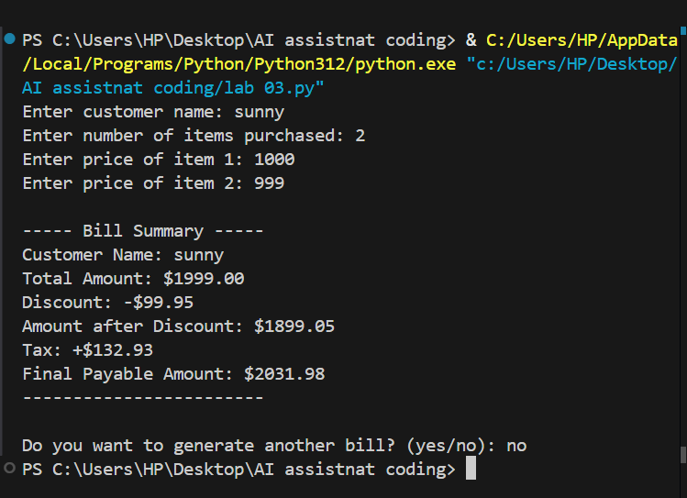
Observation:
-> The program effectively automates the billing process for a retail store.
-> It captures customer details, item information, and calculates the total bill with applicable discounts and taxes.
-> The loop allows for multiple bills to be generated until the user decides to stop, making it user-friendly for cashiers.
-> The code is structured well with functions for calculating discounts and taxes, enhancing readability and maintainability.

